GuessingGame Mastery Assignment
Reflection Log
Stefan S
CSE 2140 2nd Language Programming
(GuessingGame.java)
How has your program changed from planning to coding to now? Explain.
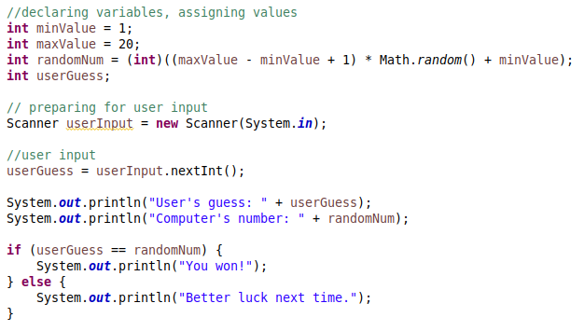
First working version of the program. There has been no changes from planning to execution. There has also been no errors. I probably would have had more errors if it weren’t for Eclipse. It catches all my syntax errors and underlines them in red before I can run the program.

To test that the “you won!” text works, I added a print statement directly after we assigned randomNum, so that I could write that number back into the input field.
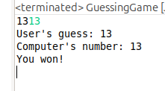

To test that the “Better Luck Next time” text worked, I simply had to run the program. I have a 1 in 20 chance of getting my guess wrong anyways.

After testing that the basic program worked, I went to add a try-except loop to the user’s input. This also went flawlessly.
I had no errors while writing this program. Eclipse caught all my errors before they happened. My program did not change from my initial planning.

